[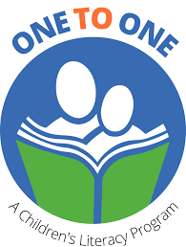](https://www.google.com/imgres?imgurl=https%3A%2F%2Fmiro.medium.com%2Fmax%2F1378%2F1*pIjQn_ff11_FLVJSLmT8og.png&imgrefurl=https%3A%2F%2Fmedium.com%2F%40yunchou0510%2Fui-case-study-web-design-development-one-to-one-literacy-1d7bf1fb63c6&tbnid=1lpDj0BR9nwi-M&vet=10CAkQxiAoAWoXChMI8Ir4k8a98AIVAAAAAB0AAAAAEAM..i&docid=E50sqrwR8EByZM&w=689&h=909&itg=1&q=one%20to%20one%20children's%20reading%20program%20logo%20image&client=firefox-b-d&ved=0CAkQxiAoAWoXChMI8Ir4k8a98AIVAAAAAB0AAAAAEAM)

**WORD GAMES**

**and**

**ACTIVITIES**

**a resource book of word games and activities for ONE TO ONE tutoring sessions**



**2023**

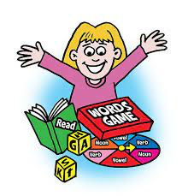

**INTRODUCTION**

**to**

**WORD GAMES**

**This section describes how word games can support ONE TO ONE tutoring sessions. It includes:**

Playing With Words

Quotes From Research

**BASIC**

**WORD LISTS**

**This section describes and lists the Dolch and Fry basic word lists used in the games described in this binder. It has the following information:**

Introduction to Word Lists

Dolch 220 word list by grade

Dolch noun list

Fry’s first 100 words

Fry’s second 100 words

Fry’s third 100 words

**WORD GAMES**

**and**

**ACTIVITIES**

**This section describes word games and activities that can be used during ONE TO ONE tutoring sessions. Included are:**

Activities Using Individual Letters

Games Using High Frequency Word Cards

Additional Word Games and Activities

Games and Activities with Dice

**EXTENDED ACTIVITIES**

**This section describes further activities to support ONE TO ONE tutoring sessions. They are.**

Small White Board Activities

Alternate Activities and Games

Games with Sounds

Games with Words

**GAME CARDS**

**This section includes templates for the word cards to use in the games described in this handbook.**

Dolch words

Cards for Lucky Duck and PIG

STOP cards

Individual Letter Cards

**WORK SHEETS**

**This section includes templates for the worksheets that accompany the games described in this handbook.**

Game Boards

Tic Tac Toe

Hang Man (original format)

Alternate Hang Man format

Boggle

Spelling Battleship

Roll, Pick a Letter, Build a Word

Roll, Say, Keep

Roll to Write a Word

Roll and Retell

How? Who? What? When? Why? Where?

K, W, L

Fold and Cut Booklets

Finding Right Fit Books

Word Searches

**GAME DESCRIPTIONS**

**This section includes handouts describing the individual games that can be used during ONE TO ONE tutoring sessions. Included are:**

Go Fish

Concentration (Memory)

Word War

Stop

Lucky Duck (NOT)

Pig And Stop

Game Boards

TIC TAC TOE

Hangman

Boggle

Roll to Write a Word

Roll, Pick A Letter, Write A Word

Roll, Say, Keep

Roll And Retell